Orycterope Transalpin IT test

Assembling the workstation

Inserting / Changing RAM
- Open the side panel with the lever
- Remove the CPU dust protection
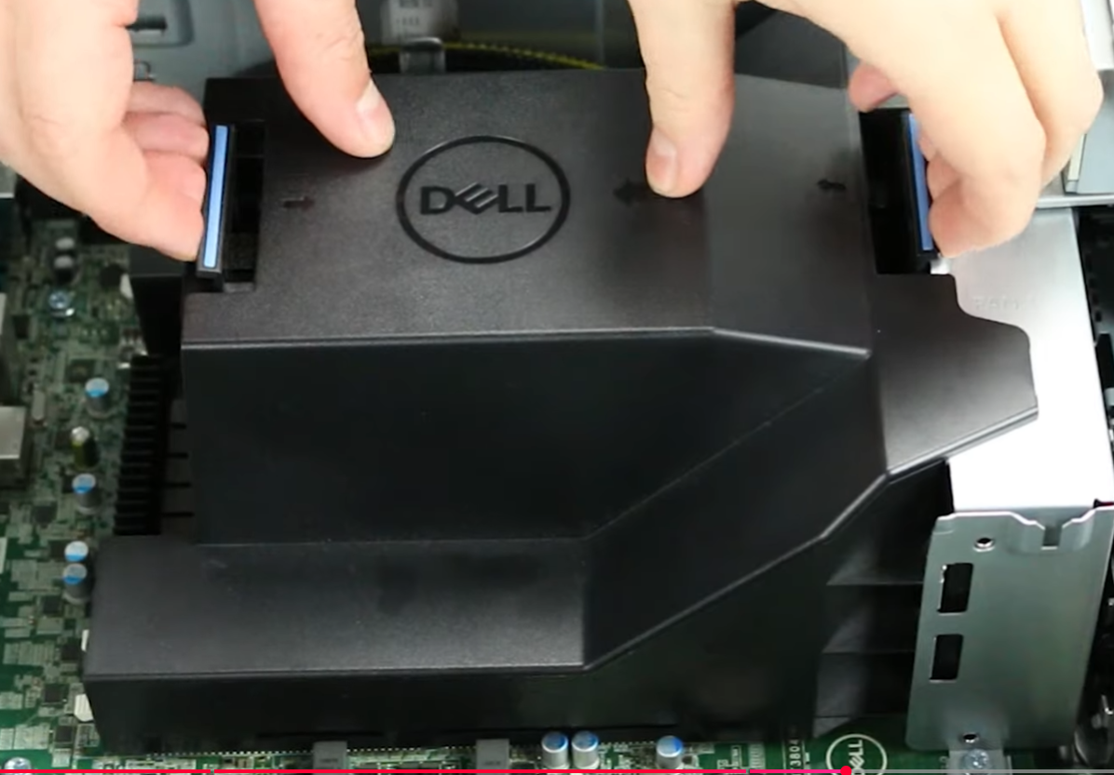
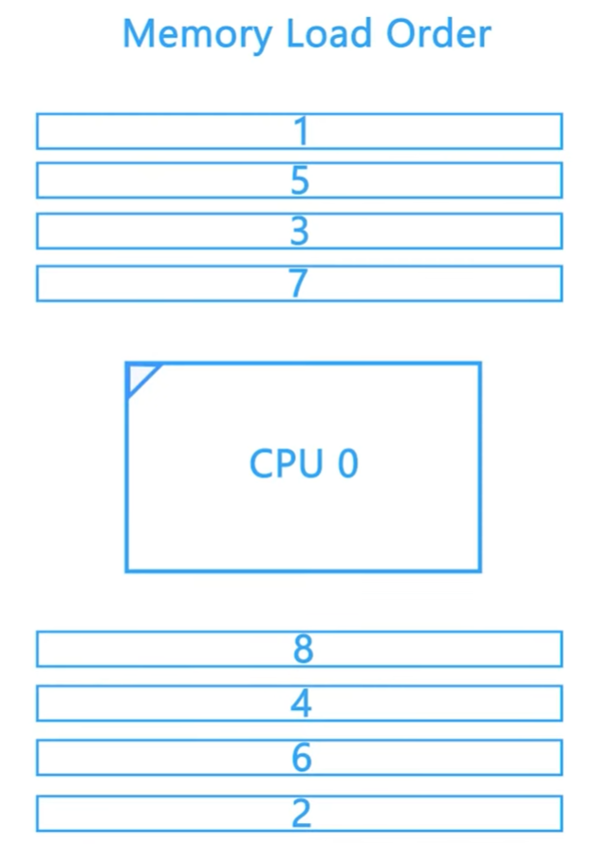
- Insert ram sticks while following the RAM order from the motherboard
Result
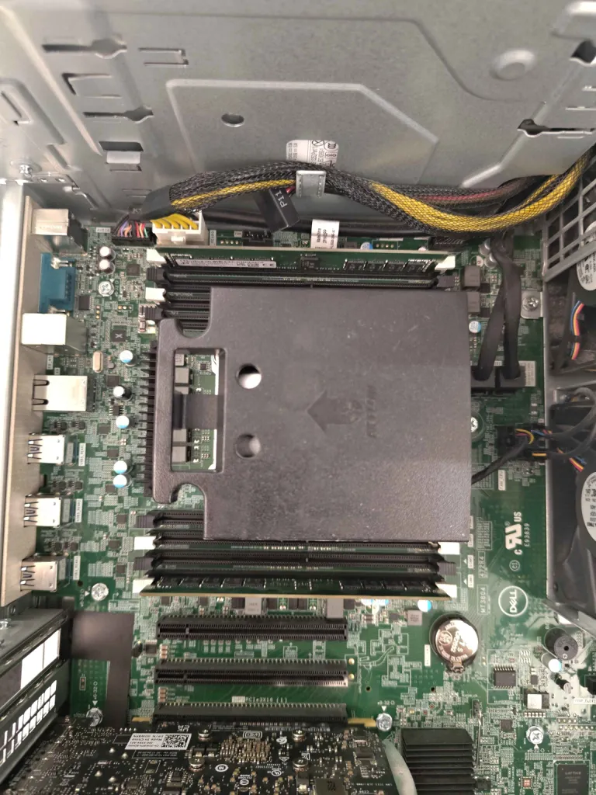

Inserting / Changing Graphic card
- Open the locks on the side (blue switches)
- Remove one of the PCI-e cover
- Insert Graphic card
Result
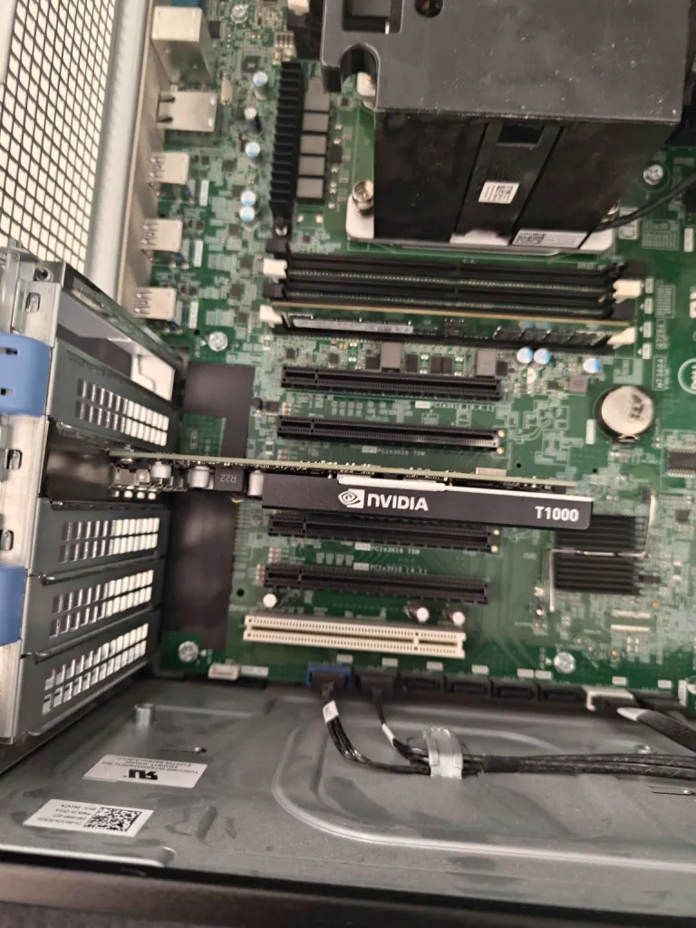

What is ansible
Ansible is a automatization tool for linux, that allows you to manage a whole IT parc. You can use inventories, groups of workstations or even target one workstation, and make them run what we call a playbook. A playbook is basically a list of tasks you’ll ask the remote workstations to do.

Install ansible
- Open a terminal
- Type the following commands

sudo apt update
sudo apt install software-properties-common
sudo add-apt-repository --yes --update ppa:ansible/ansible
sudo apt install ansible

We always start by updating apt, to be sure we retrieve the lasts versions of packages we want to install.
Then we install a common packages used by ansible. It will mostly be already installed but it doesn’t hurt to check first.
After that we update the apt’s repository, so we can add the ansible repos.
And then, we can finally install apt.

- It will prompt for the root password, type it
- It will ask you 2-3 times if you’re sure you want to install, type yes

Creating the playbook to install Docker
- First, we need Ansible to be installed.
- Create a folder (on the Desktop for me)
- In this folder, we will create 2 files. One for the inventory and the other one for the playbook.
- The inventory file is used to let you manage multiples workstations at once.
  - It can be either a .ini file or a .yaml file, but ansible recommend using .ini file for the scability.
  - Since it is a test scenario, we will create only one group of workstations and set only our local workstations
  - Here is the content of the file.
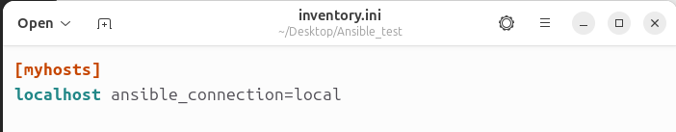
  - You can check if your inventory works by opening a terminal and typing this command

ansible myhosts -m ping -i inventory.ini

  - It should return you a success like this.

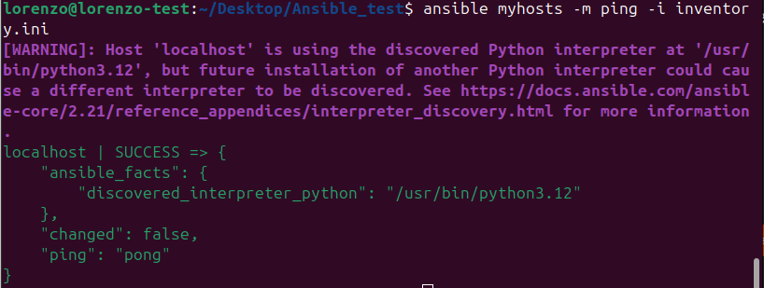
- The playbook, is a series of task you will ask Ansible to perform.
  - You need to create a .yaml file (in my case it’s docker_playbook.yaml)
  - The file is segmented in different sections.
    - Global configurations
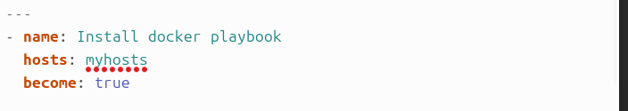
      - Name : the name of the playbook
      - hosts : the group of hosts to target from our inventory file (can be set to ALL)
      - become : keep the privileges according (Will then ask to be performed as root)
    - Tasks
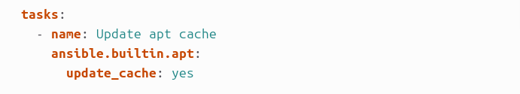
      - Name : the name of the task
      - Module : It is the module that ansible will use to perform your task. There is a large variety of module in the builtin library and you can probably download new modules from the community or develop your own.

Result
The playbook did not run by himself the first time. See the problem encountered section at the end of the documentation. After the modifications, it did without errors.

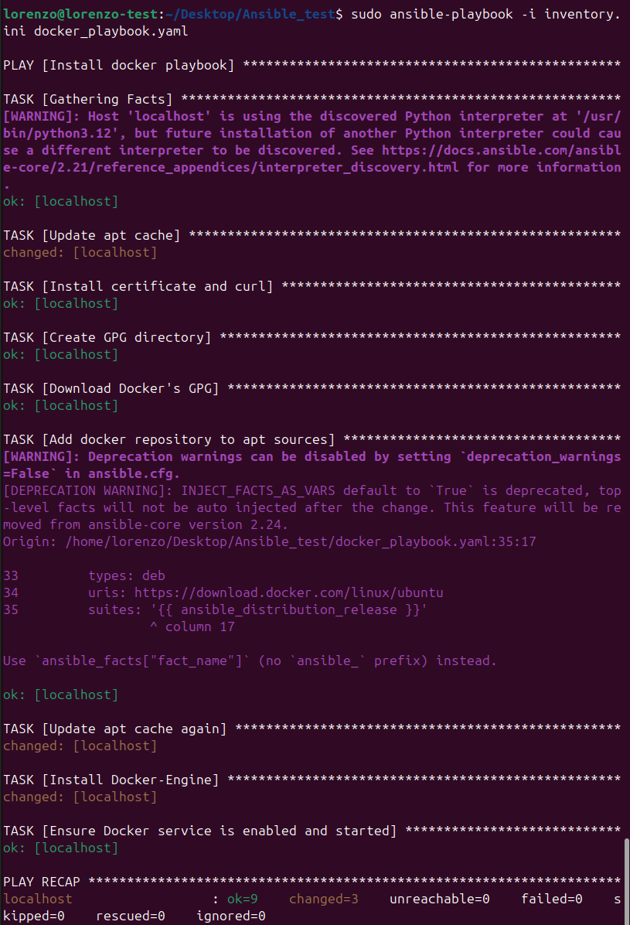
As asked in the task, we can check the docker version by taping the command
docker --version

and see that we are in the correct version

Problem encountered

Docker version 25.0.5 not available on ubuntu 24.04
After my first run of the playbook, there was an error.
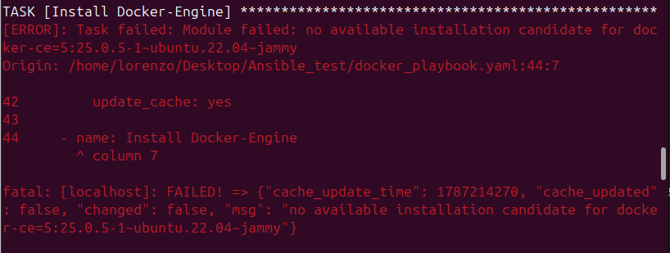
This error occurred when Ansible tried to install Docker version 25.0.5 as asked. After checking manually, the version 25.0.5 is not available on Ubuntu 24.04 noble.

I noticed Artur on that fact and told me to install the first version available that is the 26.0.0.
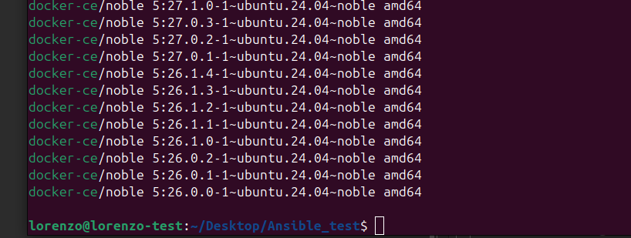
To see all the versions available, type the command
apt list --all-versions docker-ce

I then modified my playbook by replacing the version of docker to install
